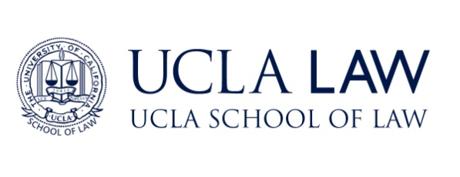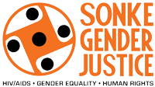

UCLA Law - Sonke Health & Human Rights Fellowship
A joint project of Sonke Gender Justice and the UCLA School of Law

APPLICATION FOR 2019-2020

You must complete the online application for UCLA School of Law’s Master of Law (LL.M.) programme and this supplemental form. UCLA School of Law will waive your US $85 application fee for the LL.M. programme. The online application instructions are available at www.law.ucla.edu/llm.

- Name (Surname / First / Middle):___________________________________________________

- What was the primary language of instruction at your law school?_______________________

- Languages & level of proficiency (beginning/intermediate/advanced/fluent):

_______________________________________________________________________________

_______________________________________________________________________________

- If awarded the UCLA Law - Sonke Health & Human Rights Fellowship, as a condition of your award you will be asked to certify that you will return to Africa upon completion of your LL.M. degree, and commit to a career that promotes health, human rights, and gender equality for at least a year after your studies. Please indicate whether you have reservations about making this certification.

______________________________________________________________________________

______________________________________________________________________________

- As a requirement of the UCLA Law - Sonke Health & Human Rights Fellowship, you will need to write a substantive analytic paper on a health, human rights, and/or gender-equality related legal issue facing South Africa. Please indicate one or two potential paper topics for this requirement.

______________________________________________________________________________

______________________________________________________________________________

______________________________________________________________________________
- Please write a personal statement incorporating responses to the following, to be submitted through UCLA Law’s online LL.M. application system. Please note that this personal statement is in lieu of the personal statement required through UCLA Law’s online LL.M. application system. This should be typed in 12-point font and should not exceed three pages in length.
  - Explain your personal and career objectives in pursuing the UCLA Law - Sonke Health & Human Rights Fellowship.
  - Describe how the fellowship might help you to advance the goals of gender equality, human rights, and/or HIV prevention in Africa.
  - Discuss any attributes, experiences, or interests that would enable you to make a distinctive contribution to UCLA Law and the public interest legal profession in South Africa.

Please send your completed form and attachments via email to llm@law.ucla.edu (PDF preferred.) The deadline is February 1, 2019. Please direct questions about the fellowship to hhrfellowship@genderjustice.org.za and questions about UCLA School of Law’s online LL.M. application procedure to llm@law.ucla.edu.

